Combined Conditions

Definition
# Source: AI Source: Provided by: [Data Path: Persons Table -> ID Column: 1, Name_En Column: Motasem Essam] -> From: [ChatGPT] on [7/25/2026]
Combined Conditions are geometric conditions that require two or more different geometric requirements to be satisfied simultaneously.
A combined condition may involve distance, length, angle, equality, incidence, parallelism, perpendicularity, ratio, area, position, intersection, symmetry, transformation, or other conditions.
For conditions $C_{1},C_{2},…,C_{n}$, a combined condition commonly has the form:
$$\boxed{C_{1}∧C_{2}∧⋯∧C_{n}}$$
where all conditions must be satisfied.

Simple Definition
# Source: AI Source: Provided by: [Data Path: Persons Table -> ID Column: 1, Name_En Column: Motasem Essam] -> From: [ChatGPT] on [7/25/2026]
A Combined Condition is a geometric requirement formed by combining multiple geometric conditions into one complete requirement.

Main Structure
# Source: AI Source: Provided by: [Data Path: Persons Table -> ID Column: 1, Name_En Column: Motasem Essam] -> From: [ChatGPT] on [7/25/2026]
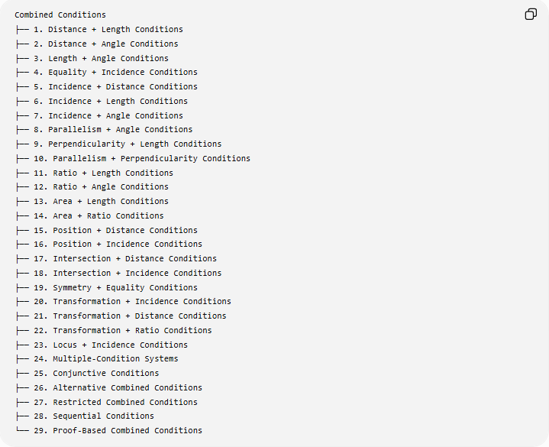
Combined Conditions
├── 1. Distance + Length Conditions
├── 2. Distance + Angle Conditions
├── 3. Length + Angle Conditions
├── 4. Equality + Incidence Conditions
├── 5. Incidence + Distance Conditions
├── 6. Incidence + Length Conditions
├── 7. Incidence + Angle Conditions
├── 8. Parallelism + Angle Conditions
├── 9. Perpendicularity + Length Conditions
├── 10. Parallelism + Perpendicularity Conditions
├── 11. Ratio + Length Conditions
├── 12. Ratio + Angle Conditions
├── 13. Area + Length Conditions
├── 14. Area + Ratio Conditions
├── 15. Position + Distance Conditions
├── 16. Position + Incidence Conditions
├── 17. Intersection + Distance Conditions
├── 18. Intersection + Incidence Conditions
├── 19. Symmetry + Equality Conditions
├── 20. Transformation + Incidence Conditions
├── 21. Transformation + Distance Conditions
├── 22. Transformation + Ratio Conditions
├── 23. Locus + Incidence Conditions
├── 24. Multiple-Condition Systems
├── 25. Conjunctive Conditions
├── 26. Alternative Combined Conditions
├── 27. Restricted Combined Conditions
├── 28. Sequential Conditions
└── 29. Proof-Based Combined Conditions

1. Distance + Length Conditions
# Source: AI Source: Provided by: [Data Path: Persons Table -> ID Column: 1, Name_En Column: Motasem Essam] -> From: [ChatGPT] on [7/25/2026]
Definition
These combine a distance requirement with a segment-length requirement.
Example
Find $P$such that:
$$PA=5$$
and:
$$AB=10$$
The complete condition is:
$$\boxed{PA=5∧AB=10}$$
The first condition determines the location of $P$relative to $A$, while the second specifies the length of segment $AB$.

2. Distance + Angle Conditions
# Source: AI Source: Provided by: [Data Path: Persons Table -> ID Column: 1, Name_En Column: Motasem Essam] -> From: [ChatGPT] on [7/25/2026]
Definition
These require both a particular distance and a particular angle.
Example
A point $P$must satisfy:
$$PA=5$$
and:
$$∠PAB={60}^{∘}$$
Therefore:
$$\boxed{PA=5∧m∠PAB={60}^{∘}}$$
The distance condition places $P$on a circle centered at $A$, while the angle condition restricts its position on that circle.

3. Length + Angle Conditions
# Source: AI Source: Provided by: [Data Path: Persons Table -> ID Column: 1, Name_En Column: Motasem Essam] -> From: [ChatGPT] on [7/25/2026]
Definition
These combine specified lengths with specified angles.
Example
A triangle satisfies:
$$AB=6$$
and:
$$m∠A={60}^{∘}$$
Thus:
$$\boxed{AB=6∧m∠A={60}^{∘}}$$
This type of condition is common in triangle construction.

4. Equality + Incidence Conditions
# Source: AI Source: Provided by: [Data Path: Persons Table -> ID Column: 1, Name_En Column: Motasem Essam] -> From: [ChatGPT] on [7/25/2026]
Definition
These require an object to lie on another object while satisfying an equality.
Example
Point $M$lies on segment $AB$and divides it into two equal parts:
$$M∈\overset{‾}{AB}$$
and:
$$AM=MB$$
Therefore:
$$\boxed{M∈\overset{‾}{AB}∧AM=MB}$$
This defines $M$as the midpoint of $AB$.

5. Incidence + Distance Conditions
# Source: AI Source: Provided by: [Data Path: Persons Table -> ID Column: 1, Name_En Column: Motasem Essam] -> From: [ChatGPT] on [7/25/2026]
Definition
These require a point to lie on a geometric object and simultaneously satisfy a distance condition.
Example
$$P∈\overset{‾}{AB}$$
and:
$$PC=4$$
Therefore:
$$\boxed{P∈\overset{‾}{AB}∧PC=4}$$
Geometrically, $P$is obtained from:
$$\overset{‾}{AB}∩C\left(C , 4\right)$$
where $C\left(C , 4\right)$denotes the circle centered at $C$with radius $4$.

6. Incidence + Length Conditions
# Source: AI Source: Provided by: [Data Path: Persons Table -> ID Column: 1, Name_En Column: Motasem Essam] -> From: [ChatGPT] on [7/25/2026]
Definition
These combine membership in a geometric object with a specified segment length.
Example
$$D∈\overset{‾}{BC}$$
and:
$$BD=3$$
Thus:
$$\boxed{D∈\overset{‾}{BC}∧BD=3}$$
If:
$$BC=10$$
then:
$$DC=7$$
by the segment-addition relationship:
$$BD+DC=BC.$$

7. Incidence + Angle Conditions
# Source: AI Source: Provided by: [Data Path: Persons Table -> ID Column: 1, Name_En Column: Motasem Essam] -> From: [ChatGPT] on [7/25/2026]
Definition
These require a point or line to belong to a geometric configuration while also satisfying an angle requirement.
Example
$$D∈\overset{‾}{BC}$$
and:
$$∠BAD={30}^{∘}$$
Therefore:
$$\boxed{D∈\overset{‾}{BC}∧m∠BAD={30}^{∘}}$$
This can determine a specific point $D$on $BC$.

8. Parallelism + Angle Conditions
# Source: AI Source: Provided by: [Data Path: Persons Table -> ID Column: 1, Name_En Column: Motasem Essam] -> From: [ChatGPT] on [7/25/2026]
Definition
These combine a parallelism requirement with one or more angle requirements.
Example
$$l_{1}∥l_{2}$$
and:
$$m∠A={60}^{∘}.$$
Therefore:
$$\boxed{l_{1}∥l_{2}∧m∠A={60}^{∘}}$$
If a transversal intersects the parallel lines, corresponding and alternate interior angles can determine other angles.

9. Perpendicularity + Length Conditions
# Source: AI Source: Provided by: [Data Path: Persons Table -> ID Column: 1, Name_En Column: Motasem Essam] -> From: [ChatGPT] on [7/25/2026]
Definition
These require objects to be perpendicular while also specifying a length.
Example
$$AD⊥BC$$
and:
$$AD=8.$$
Therefore:
$$\boxed{AD⊥BC∧AD=8}$$
This describes an altitude of length $8$.

10. Parallelism + Perpendicularity Conditions
# Source: AI Source: Provided by: [Data Path: Persons Table -> ID Column: 1, Name_En Column: Motasem Essam] -> From: [ChatGPT] on [7/25/2026]
Definition
These combine parallel and perpendicular relationships.
Example
$$AB∥CD$$
and:
$$AB⊥BC.$$
Therefore:
$$\boxed{AB∥CD∧AB⊥BC}$$
This is part of the structure of a rectangle.

11. Ratio + Length Conditions
# Source: AI Source: Provided by: [Data Path: Persons Table -> ID Column: 1, Name_En Column: Motasem Essam] -> From: [ChatGPT] on [7/25/2026]
Definition
These specify both a ratio and an absolute length.
Example
Suppose:
$$AB:BC=2:3$$
and:
$$AC=20.$$
Since:
$$AB+BC=20,$$
let:
$$AB=2x, BC=3x.$$
Then:
$$5x=20$$
so:
$$x=4.$$
Therefore:
$$\boxed{AB=8, BC=12}$$

12. Ratio + Angle Conditions
# Source: AI Source: Provided by: [Data Path: Persons Table -> ID Column: 1, Name_En Column: Motasem Essam] -> From: [ChatGPT] on [7/25/2026]
Definition
These combine proportional angle relationships with angle restrictions.
Example
Suppose:
$$A:B=2:3$$
and $A,B$are supplementary:
$$A+B={180}^{∘}.$$
Let:
$$A=2x, B=3x.$$
Then:
$$5x={180}^{∘}$$
so:
$$x={36}^{∘}.$$
Therefore:
$$\boxed{A={72}^{∘}, B={108}^{∘}}$$

13. Area + Length Conditions
# Source: AI Source: Provided by: [Data Path: Persons Table -> ID Column: 1, Name_En Column: Motasem Essam] -> From: [ChatGPT] on [7/25/2026]
Definition
These combine an area requirement with one or more lengths.
Example
A rectangle satisfies:
$$A=48$$
and:
$$AB=8.$$
Since:
$$A=lw,$$
we obtain:
$$48=8w$$
and therefore:
$$\boxed{w=6}.$$

14. Area + Ratio Conditions
# Source: AI Source: Provided by: [Data Path: Persons Table -> ID Column: 1, Name_En Column: Motasem Essam] -> From: [ChatGPT] on [7/25/2026]
Definition
These combine an area relationship with a ratio.
Example
Two similar figures have linear scale factor:
$$k=2.$$
Their areas therefore satisfy:
$$\frac{A_{2}}{A_{1}}=k^{2}=4.$$
If:
$$A_{1}=15,$$
then:
$$\boxed{A_{2}=60}.$$
The combined condition is:
$$\boxed{\text{Similarity ratio}=2∧\text{Area ratio}=4}$$

15. Position + Distance Conditions
# Source: AI Source: Provided by: [Data Path: Persons Table -> ID Column: 1, Name_En Column: Motasem Essam] -> From: [ChatGPT] on [7/25/2026]
Definition
These specify both where an object is located and how far it is from another object.
Example
A point $P$must be:
- inside a circle of radius $10$,
- exactly $4$units from its center.
Then:
$$OP=4<10.$$
Therefore:
$$\boxed{P\text{ is inside the circle}∧OP=4}$$

16. Position + Incidence Conditions
# Source: AI Source: Provided by: [Data Path: Persons Table -> ID Column: 1, Name_En Column: Motasem Essam] -> From: [ChatGPT] on [7/25/2026]
Definition
These combine a positional restriction with membership in a geometric object.
Example
$$P∈\overset{‾}{AB}$$
and $P$must lie in the upper half-plane:
$$y>0.$$
Therefore:
$$\boxed{P∈\overset{‾}{AB}∧y>0}$$
Only the portion of $AB$satisfying the positional restriction is allowed.

17. Intersection + Distance Conditions
# Source: AI Source: Provided by: [Data Path: Persons Table -> ID Column: 1, Name_En Column: Motasem Essam] -> From: [ChatGPT] on [7/25/2026]
Definition
These require an object to belong to an intersection while satisfying a distance condition.
Example
Find $P$such that:
$$P∈l$$
and:
$$PA=5.$$
Therefore:
$$\boxed{P∈l∩C\left(A , 5\right)}$$
The solutions are the intersection points of the line and circle.
Depending on their relative positions, there may be:
- 0 solutions,
- 1 solution,
- 2 solutions.

18. Intersection + Incidence Conditions
# Source: AI Source: Provided by: [Data Path: Persons Table -> ID Column: 1, Name_En Column: Motasem Essam] -> From: [ChatGPT] on [7/25/2026]
Definition
These require a point to belong simultaneously to multiple geometric objects.
Example
$$P∈l_{1}$$
and:
$$P∈l_{2}.$$
Therefore:
$$\boxed{P∈l_{1}∩l_{2}}$$
If the lines intersect at one point:
$$\boxed{l_{1}∩l_{2}=\left\{P\right\}}$$

19. Symmetry + Equality Conditions
# Source: AI Source: Provided by: [Data Path: Persons Table -> ID Column: 1, Name_En Column: Motasem Essam] -> From: [ChatGPT] on [7/25/2026]
Definition
These combine a symmetry requirement with equality of geometric quantities.
Example
If $l$is a reflection axis for points $A$and $A^{'}$, then:
$$AA^{'}⊥l$$
and:
$$d\left(A , l\right)=d\left(A^{'} , l\right).$$
Thus:
$$\boxed{R_{l}\left(A\right)=A^{'}∧d\left(A , l\right)=d\left(A^{'} , l\right)}$$
The equality condition verifies the mirror relationship.

20. Transformation + Incidence Conditions
# Source: AI Source: Provided by: [Data Path: Persons Table -> ID Column: 1, Name_En Column: Motasem Essam] -> From: [ChatGPT] on [7/25/2026]
Definition
These require a transformed object to satisfy an incidence relationship.
Example
Point $P^{'}$is the reflection of $P$across $l$, and $P^{'}$lies on $m$:
$$P^{'}=R_{l}\left(P\right)$$
and:
$$P^{'}∈m.$$
Therefore:
$$\boxed{P^{'}=R_{l}\left(P\right)∧P^{'}∈m}$$
This can be used to locate $P^{'}$.

21. Transformation + Distance Conditions
# Source: AI Source: Provided by: [Data Path: Persons Table -> ID Column: 1, Name_En Column: Motasem Essam] -> From: [ChatGPT] on [7/25/2026]
Definition
These combine a transformation requirement with a distance requirement.
Example
A point $P^{'}$is the image of $P$under a rotation and must satisfy:
$$P^{'}Q=6.$$
Thus:
$$\boxed{P^{'}=R_{O,θ}\left(P\right)∧P^{'}Q=6}$$
Because rotation preserves distances:
$$P^{'}Q=PQ$$
when $Q$is transformed correspondingly.

22. Transformation + Ratio Conditions
# Source: AI Source: Provided by: [Data Path: Persons Table -> ID Column: 1, Name_En Column: Motasem Essam] -> From: [ChatGPT] on [7/25/2026]
Definition
These require a transformation together with a proportional relationship.
Example
A dilation has scale factor:
$$k=3$$
and:
$$AB=4.$$
Then:
$$A^{'}B^{'}=3\left(4\right)=12.$$
Therefore:
$$\boxed{\frac{A^{'}B^{'}}{AB}=3}$$

23. Locus + Incidence Conditions
# Source: AI Source: Provided by: [Data Path: Persons Table -> ID Column: 1, Name_En Column: Motasem Essam] -> From: [ChatGPT] on [7/25/2026]
Definition
These combine a locus condition with membership in another geometric object.
Example
Suppose:
$$PA=PB.$$
The locus is the perpendicular bisector of $AB$.
If $P$must also lie on line $l$, then:
$$\boxed{P∈\text{Perpendicular Bisector}\left(AB\right)∩l}$$
Thus, the combined condition may produce zero, one, or multiple solutions.

24. Multiple-Condition Systems
# Source: AI Source: Provided by: [Data Path: Persons Table -> ID Column: 1, Name_En Column: Motasem Essam] -> From: [ChatGPT] on [7/25/2026]
Definition
A Multiple-Condition System contains several conditions that must all hold simultaneously.
Example
Find $P$satisfying:
$$P∈\overset{‾}{AB} \\ PA=5 \\ PC=7 \\ ∠APC={90}^{∘}.$$
The complete system is:
$$\boxed{P∈\overset{‾}{AB}∧PA=5∧PC=7∧m∠APC={90}^{∘}}$$
Each condition restricts the possible solutions.

25. Conjunctive Conditions
# Source: AI Source: Provided by: [Data Path: Persons Table -> ID Column: 1, Name_En Column: Motasem Essam] -> From: [ChatGPT] on [7/25/2026]
Definition
A Conjunctive Condition combines requirements using logical AND.
$$\boxed{C_{1}∧C_{2}}$$
means both $C_{1}$and $C_{2}$must be true.
Example
$$P∈l$$
and:
$$PA=5.$$
Then:
$$\boxed{P∈l∧PA=5}$$
Geometrically:
$$\boxed{P∈l∩C\left(A , 5\right)}$$

26. Alternative Combined Conditions
# Source: AI Source: Provided by: [Data Path: Persons Table -> ID Column: 1, Name_En Column: Motasem Essam] -> From: [ChatGPT] on [7/25/2026]
Definition
An Alternative Combined Condition allows one of several conditions to be satisfied.
It uses logical OR:
$$\boxed{C_{1}∨C_{2}}$$
Example
A point $P$may satisfy:
$$PA=5$$
or:
$$PB=5.$$
Therefore:
$$\boxed{PA=5∨PB=5}$$
The solution set is:
$$\boxed{C\left(A , 5\right)∪C\left(B , 5\right)}$$
This differs fundamentally from an AND condition.

27. Restricted Combined Conditions
# Source: AI Source: Provided by: [Data Path: Persons Table -> ID Column: 1, Name_En Column: Motasem Essam] -> From: [ChatGPT] on [7/25/2026]
Definition
A Restricted Combined Condition combines a geometric condition with one or more restrictions on the allowed region.
Example
A point must satisfy:
$$PA=5$$
and:
$$x>0.$$
Thus:
$$\boxed{PA=5∧x>0}$$
The complete locus is only the portion of the circle lying in the right half-plane.

28. Sequential Conditions
# Source: AI Source: Provided by: [Data Path: Persons Table -> ID Column: 1, Name_En Column: Motasem Essam] -> From: [ChatGPT] on [7/25/2026]
Definition
A Sequential Condition requires several geometric operations or transformations to occur in a specified order.
If $T_{1}$occurs first and $T_{2}$second:
$$\boxed{T=T_{2}∘T_{1}}$$
Example
- Reflect across the $x$-axis.
- Translate by $\left(3 , 2\right)$.
The transformation is:
$$\boxed{T=T_{\left(3 , 2\right)}∘R_{x}}$$
The order matters.

29. Proof-Based Combined Conditions
# Source: AI Source: Provided by: [Data Path: Persons Table -> ID Column: 1, Name_En Column: Motasem Essam] -> From: [ChatGPT] on [7/25/2026]
Definition
A Proof-Based Combined Condition uses multiple known conditions to establish a conclusion.
Example
Given:
$$AB=AC$$
and:
$$AD\text{ bisects }∠A.$$
We can combine these conditions with the angle-bisector relationship to prove:
$$△ABD≅△ACD.$$
Then:
$$BD=DC.$$
The proof structure is:
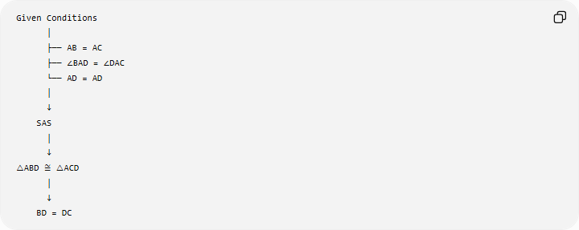
Given Conditions
│
├── AB = AC
├── ∠BAD = ∠DAC
└── AD = AD
│
↓
SAS
│
↓
△ABD ≅ △ACD
│
↓
BD = DC

Combined Conditions as Set Intersections
# Source: AI Source: Provided by: [Data Path: Persons Table -> ID Column: 1, Name_En Column: Motasem Essam] -> From: [ChatGPT] on [7/25/2026]
Many combined geometric conditions can be understood using set intersection.
Suppose:
$$C_{1}→L_{1}$$
and:
$$C_{2}→L_{2}.$$
If both must hold:
$$\boxed{L=L_{1}∩L_{2}}$$
Example
$$PA=5$$
gives a circle:
$$L_{1}=C\left(A , 5\right)$$
while:
$$PB=4$$
gives:
$$L_{2}=C\left(B , 4\right).$$
Therefore:
$$\boxed{L=C\left(A , 5\right)∩C\left(B , 4\right)}$$
The possible points are the common intersection points of the two circles.

AND vs OR in Combined Conditions
# Source: AI Source: Provided by: [Data Path: Persons Table -> ID Column: 1, Name_En Column: Motasem Essam] -> From: [ChatGPT] on [7/25/2026]
This distinction is extremely important.
AND
$$\boxed{C_{1}∧C_{2}}$$
means both conditions must hold.
Geometrically:
$$\boxed{L_{1}∩L_{2}}$$
OR
$$\boxed{C_{1}∨C_{2}}$$
means at least one condition must hold.
Geometrically:
$$\boxed{L_{1}∪L_{2}}$$
Therefore:
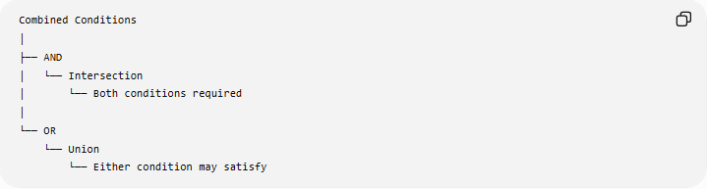
Combined Conditions
│
├── AND
│ └── Intersection
│ └── Both conditions required
│
└── OR
└── Union
└── Either condition may satisfy

Combined Conditions and Loci
# Source: AI Source: Provided by: [Data Path: Persons Table -> ID Column: 1, Name_En Column: Motasem Essam] -> From: [ChatGPT] on [7/25/2026]
A combined condition can create a more restricted locus than any individual condition.
For example:
$$PA=5$$
produces a circle.
Adding:
$$PB=4$$
produces:
$$\boxed{C\left(A , 5\right)∩C\left(B , 4\right)}$$
Adding another restriction:
$$P∈l$$
produces:
$$\boxed{C\left(A , 5\right)∩C\left(B , 4\right)∩l}$$
Each additional condition reduces the possible solution set.

Combined Conditions and Degrees of Restriction
# Source: AI Source: Provided by: [Data Path: Persons Table -> ID Column: 1, Name_En Column: Motasem Essam] -> From: [ChatGPT] on [7/25/2026]
Each condition can reduce the possible configurations.
For example:
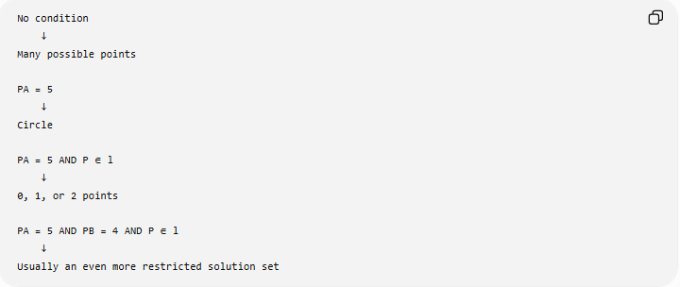
No condition
↓
Many possible points

PA = 5
↓
Circle

PA = 5 AND P ∈ l
↓
0, 1, or 2 points

PA = 5 AND PB = 4 AND P ∈ l
↓
Usually an even more restricted solution set
This is why combined conditions are fundamental in:
- geometric construction,
- coordinate geometry,
- locus problems,
- optimization,
- geometric proofs,
- constraint solving.

Important Relationships

Combined Condition and Single Condition
# Source: AI Source: Provided by: [Data Path: Persons Table -> ID Column: 1, Name_En Column: Motasem Essam] -> From: [ChatGPT] on [7/25/2026]
A single condition:
$$C_{1}$$
specifies one requirement.
A combined condition:
$$C_{1}∧C_{2}∧C_{3}$$
specifies several simultaneous requirements.

Combined Condition and Locus
# Source: AI Source: Provided by: [Data Path: Persons Table -> ID Column: 1, Name_En Column: Motasem Essam] -> From: [ChatGPT] on [7/25/2026]
$$\boxed{\text{Condition}→\text{Locus}}$$
For multiple conditions:
$$\boxed{\text{Combined Conditions}→\text{Intersection/Union of Loci}}$$

Combined Condition and Construction
# Source: AI Source: Provided by: [Data Path: Persons Table -> ID Column: 1, Name_En Column: Motasem Essam] -> From: [ChatGPT] on [7/25/2026]
$$\boxed{\text{Conditions}→\text{Loci}→\text{Intersections}→\text{Construction}}$$

Combined Condition and Proof
# Source: AI Source: Provided by: [Data Path: Persons Table -> ID Column: 1, Name_En Column: Motasem Essam] -> From: [ChatGPT] on [7/25/2026]
A geometric proof often begins with multiple given conditions:
$$C_{1},C_{2},C_{3},…$$
and uses them together to derive a conclusion:
$$\boxed{C_{1}∧C_{2}∧C_{3}⇒G}$$

Examples of Complete Combined Conditions

Example 1 — Midpoint
# Source: AI Source: Provided by: [Data Path: Persons Table -> ID Column: 1, Name_En Column: Motasem Essam] -> From: [ChatGPT] on [7/25/2026]
$$M∈\overset{‾}{AB}$$
and:
$$AM=MB.$$
Therefore:
$$\boxed{M∈\overset{‾}{AB}∧AM=MB}$$

Example 2 — Perpendicular Bisector
# Source: AI Source: Provided by: [Data Path: Persons Table -> ID Column: 1, Name_En Column: Motasem Essam] -> From: [ChatGPT] on [7/25/2026]
$$P∈l$$
and:
$$l⊥AB$$
and:
$$l\text{ passes through the midpoint of }AB.$$
Therefore, $l$is the perpendicular bisector of $AB$.

Example 3 — Angle Bisector
# Source: AI Source: Provided by: [Data Path: Persons Table -> ID Column: 1, Name_En Column: Motasem Essam] -> From: [ChatGPT] on [7/25/2026]
$$D∈\overset{‾}{BC}$$
and:
$$∠BAD=∠DAC.$$
Therefore:
$$\boxed{D∈BC∧∠BAD=∠DAC}$$

Example 4 — Rectangle
# Source: AI Source: Provided by: [Data Path: Persons Table -> ID Column: 1, Name_En Column: Motasem Essam] -> From: [ChatGPT] on [7/25/2026]
A quadrilateral can be characterized using:
$$AB∥CD \\ BC∥AD \\ AB⊥BC.$$
Thus:
$$\boxed{AB∥CD∧BC∥AD∧AB⊥BC}$$

Example 5 — Equilateral Triangle
# Source: AI Source: Provided by: [Data Path: Persons Table -> ID Column: 1, Name_En Column: Motasem Essam] -> From: [ChatGPT] on [7/25/2026]
$$AB=BC \\ BC=CA \\ CA=AB.$$
Therefore:
$$\boxed{AB=BC=CA}$$
This is a multiple equality condition describing an equilateral triangle.

Example 6 — Circumcircle Intersection
# Source: AI Source: Provided by: [Data Path: Persons Table -> ID Column: 1, Name_En Column: Motasem Essam] -> From: [ChatGPT] on [7/25/2026]
Suppose:
$$P∈C_{1}$$
and:
$$P∈C_{2}.$$
Then:
$$\boxed{P∈C_{1}∩C_{2}}$$
If the circles intersect at two points:
$$\boxed{C_{1}∩C_{2}=\left\{P , Q\right\}}$$

General Mathematical Form
# Source: AI Source: Provided by: [Data Path: Persons Table -> ID Column: 1, Name_En Column: Motasem Essam] -> From: [ChatGPT] on [7/25/2026]
A combined geometric condition can be represented as:
$$\boxed{C_{1}\left(P\right)∧C_{2}\left(P\right)∧⋯∧C_{n}\left(P\right)}$$
The solution set is:
$$\boxed{S=\bigcap_{i=1}^{n}{S_{i}}}$$
where $S_{i}$is the set of objects satisfying condition $C_{i}$.
For alternative conditions:
$$\boxed{S=\bigcup_{i=1}^{n}{S_{i}}}$$

Classification Summary
# Source: AI Source: Provided by: [Data Path: Persons Table -> ID Column: 1, Name_En Column: Motasem Essam] -> From: [ChatGPT] on [7/25/2026]
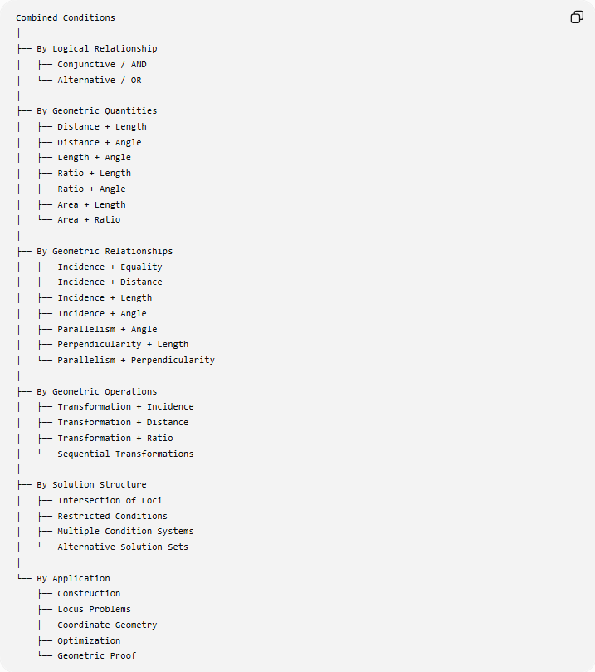
Combined Conditions
│
├── By Logical Relationship
│ ├── Conjunctive / AND
│ └── Alternative / OR
│
├── By Geometric Quantities
│ ├── Distance + Length
│ ├── Distance + Angle
│ ├── Length + Angle
│ ├── Ratio + Length
│ ├── Ratio + Angle
│ ├── Area + Length
│ └── Area + Ratio
│
├── By Geometric Relationships
│ ├── Incidence + Equality
│ ├── Incidence + Distance
│ ├── Incidence + Length
│ ├── Incidence + Angle
│ ├── Parallelism + Angle
│ ├── Perpendicularity + Length
│ └── Parallelism + Perpendicularity
│
├── By Geometric Operations
│ ├── Transformation + Incidence
│ ├── Transformation + Distance
│ ├── Transformation + Ratio
│ └── Sequential Transformations
│
├── By Solution Structure
│ ├── Intersection of Loci
│ ├── Restricted Conditions
│ ├── Multiple-Condition Systems
│ └── Alternative Solution Sets
│
└── By Application
├── Construction
├── Locus Problems
├── Coordinate Geometry
├── Optimization
└── Geometric Proof

Key Formulas
# Source: AI Source: Provided by: [Data Path: Persons Table -> ID Column: 1, Name_En Column: Motasem Essam] -> From: [ChatGPT] on [7/25/2026]
Logical AND
$$\boxed{C_{1}∧C_{2}}$$
Logical OR
$$\boxed{C_{1}∨C_{2}}$$
Intersection of Solution Sets
$$\boxed{S=S_{1}∩S_{2}}$$
Union of Solution Sets
$$\boxed{S=S_{1}∪S_{2}}$$
Multiple AND Conditions
$$\boxed{S=\bigcap_{i=1}^{n}{S_{i}}}$$
Multiple OR Conditions
$$\boxed{S=\bigcup_{i=1}^{n}{S_{i}}}$$
Transformation Condition
$$\boxed{T\left(F\right)=F^{'}}$$
Combined Transformation
$$\boxed{T=T_{2}∘T_{1}}$$
Combined Distance Conditions
$$\boxed{PA=r_{1}∧PB=r_{2}}$$
gives:
$$\boxed{P∈C\left(A , r_{1}\right)∩C\left(B , r_{2}\right)}$$

Key Points
# Source: AI Source: Provided by: [Data Path: Persons Table -> ID Column: 1, Name_En Column: Motasem Essam] -> From: [ChatGPT] on [7/25/2026]
- Combined Conditions contain two or more geometric requirements.
- The most common logical form is:
$$\boxed{C_{1}∧C_{2}}$$
- AND means every condition must be satisfied.
- OR means at least one condition may be satisfied.
- AND conditions commonly correspond to intersections of solution sets.
- OR conditions commonly correspond to unions of solution sets.
- Combined conditions are fundamental in geometric constructions.
- They are also central to locus problems.
- Multiple conditions can determine a unique point, several points, an entire figure, or no solution.
- A combined condition may mix fundamentally different types:
$$\text{incidence + distance + angle + ratio + transformation}.$$
- Additional conditions generally restrict the set of possible solutions.
- Combined conditions are frequently used to define important geometric objects such as midpoints, angle bisectors, perpendicular bisectors, altitudes, rectangles, and special loci.
- In proofs, several given conditions are combined logically to establish a conclusion.
- In coordinate geometry, combined conditions become simultaneous equations or inequalities.
- The general idea is:
$$\boxed{\text{Multiple Conditions}→\text{Common Solutions}}$$

Conclusion
# Source: AI Source: Provided by: [Data Path: Persons Table -> ID Column: 1, Name_En Column: Motasem Essam] -> From: [ChatGPT] on [7/25/2026]
Combined Conditions are geometric requirements formed by combining multiple geometric conditions into a single system. They allow geometry to express complex configurations precisely by requiring several relationships to hold simultaneously or by allowing alternative relationships.
The fundamental structure is:
$$\boxed{C_{1}∧C_{2}∧⋯∧C_{n}}$$
with solution set:
$$\boxed{S=S_{1}∩S_{2}∩⋯∩S_{n}}$$
while alternative conditions use:
$$\boxed{C_{1}∨C_{2}}$$
and correspond to:
$$\boxed{S_{1}∪S_{2}}.$$
Thus, Combined Conditions form a natural final layer of geometric constraints, bringing together distance, length, angle, equality, incidence, parallelism, perpendicularity, ratio, area, position, intersection, symmetry, transformation, and locus conditions into complete geometric configurations.

